Link and Learn: VITA Testing Portal and Training Resources

Website: [www.LinkLearnCertification.com](http://www.LinkLearnCertification.com)

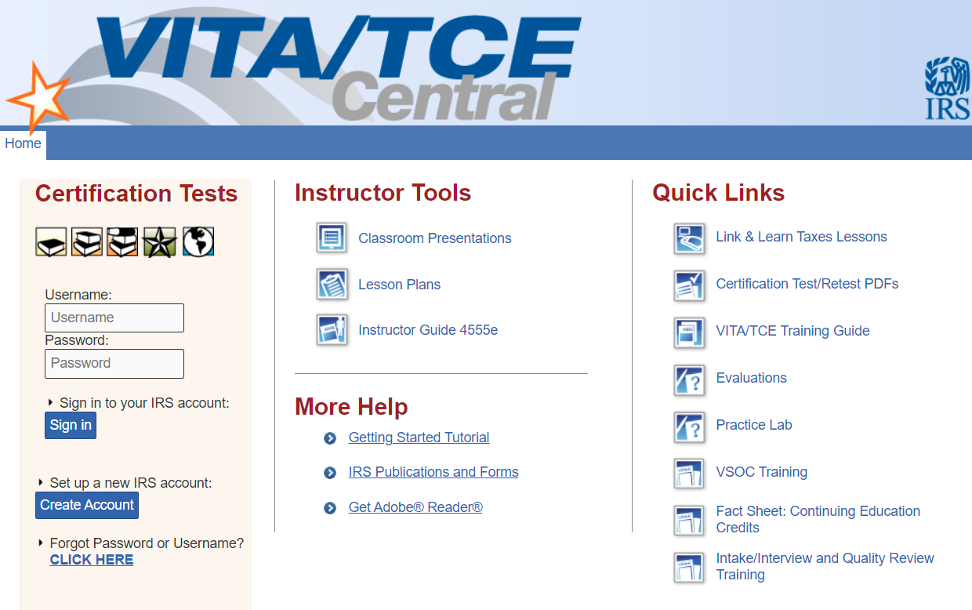





**Group** Select 01 VITA Volunteer, unless you are an IRS employee select 08

**Site Coordinator Test** Select No unless you will be a site coordinator

**Training Source** Select Other

Fill in required fields marked with * leave SEID field blank unless you are an IRS employee. Create a username and password. Password is case sensitive and must be 8 characters. Write down your credentials as you will need to access this account again and can use it in future tax seasons.

**Partner Organization** United Way of Greater Richmond and Petersburg

**Volunteer Years** First year volunteers select 1. Returning volunteers make sure the years of service is correct-this does not auto advance.

**Professional Status** Leave blank unless you are a CPA or have a PTIN.