How to Access your Volunteer Agreement (Form 13615)
Form 13615 Volunteer Standards of Conduct Agreement shows all the certification exams that you have completed. United Way is required to maintain a copy of this Agreement for all volunteers and site coordinators. All volunteers must sign and date the Volunteer Agreement to certify their adherence of the program requirements.
After completing all required certification tests for the role in which you will serve, please e-mail a PDF of the Volunteer Agreement and a photo of your Driver’s License, Identification Card or Passport to VITA Program Staff at tax@yourunitedway.org.
After logging in to your Link and Learn account you should see this view below.

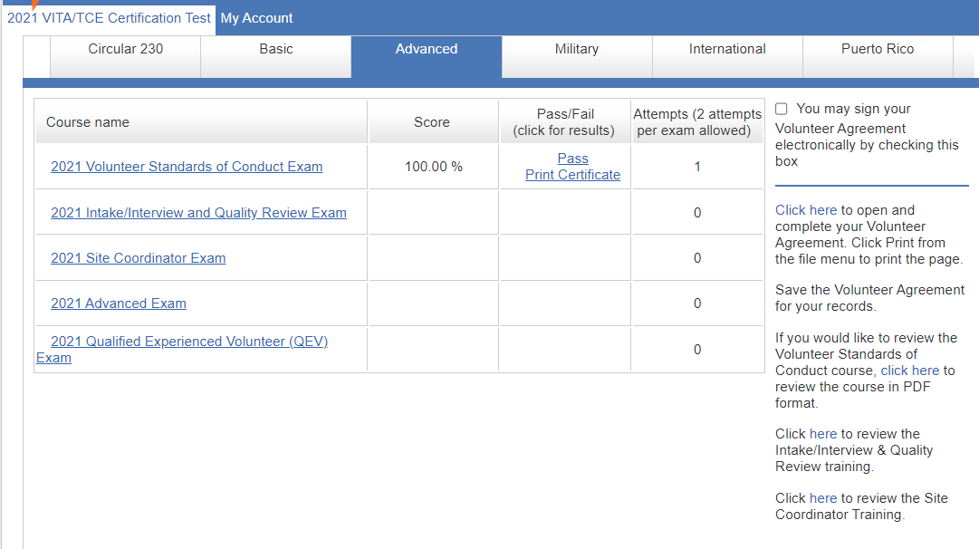
Click to open and save
1
1
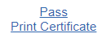
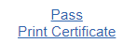
Save a PDF version on your device.
Name it with your first and last name plus “Volunteer Agreement”

Click to open and save
This is not what you need to print.
Check this box

