Link and Learn: VITA Testing Portal and Training Resources

Website: [www.LinkLearnCertification.com](http://www.LinkLearnCertification.com)

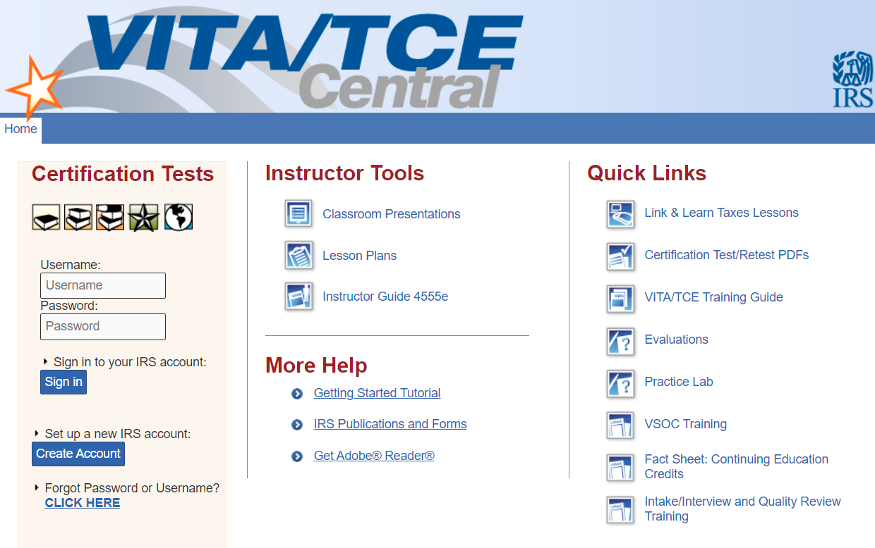





**NOTE: The name listed here must match your Government Issued ID. We are required to view this ID to verify identity. If your address is not updated on your ID you must provide us with proof of your current address.**

**Group** Select 01 VITA Volunteer, unless you are an IRS employee select 08

**Site Coordinator Test** Select No unless you will be a site coordinator

**Training Source** Select Other

Fill in required fields marked with * leave SEID field blank unless you are an IRS employee. Create a username and password. Password is case sensitive and must be 8 characters. Write down your credentials as you will need to access this account again and can use it in future tax seasons.

**Partner Organization** United Way of Greater Richmond and Petersburg

**Volunteer Years** First year volunteers select 1. Returning volunteers make sure the year of service is correct-this does not auto advance.

**Professional Status** Leave blank unless you are a CPA or have a PTIN.